**Rock, Paper, Scissors with Javascript**

**Name= Amit Babu Khatri**

**Student id=** [**np03cs4s230291@heraldcollege.edu.np**](mailto:np03cs4s230291@heraldcollege.edu.np)

**HTML CODE:**

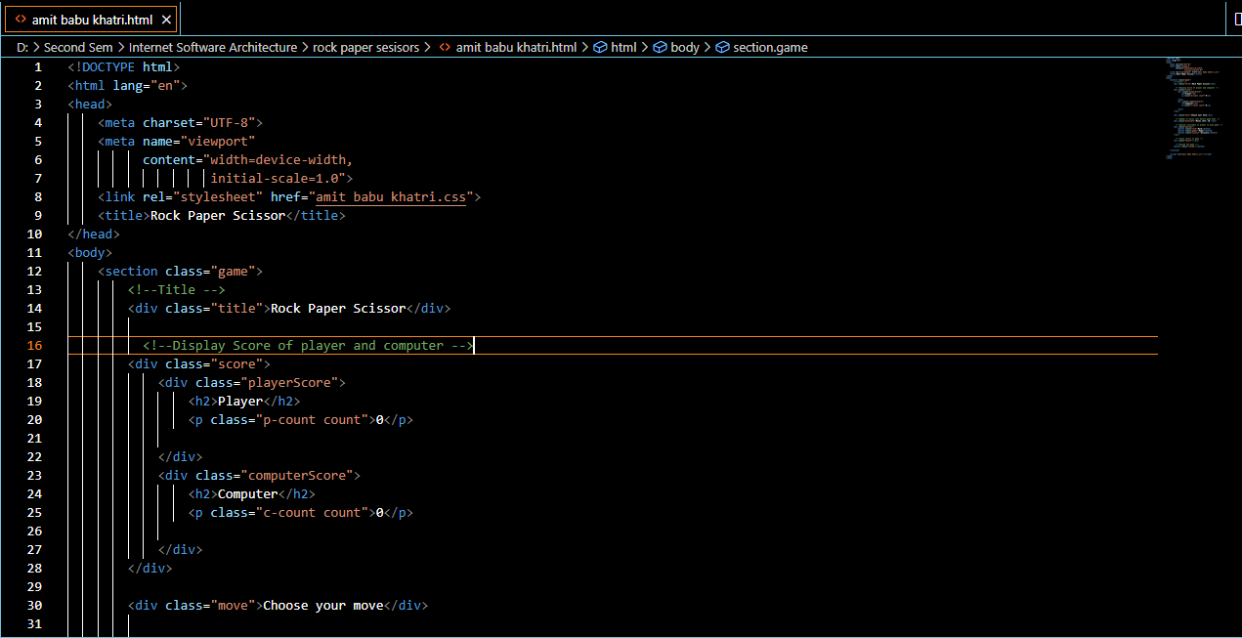

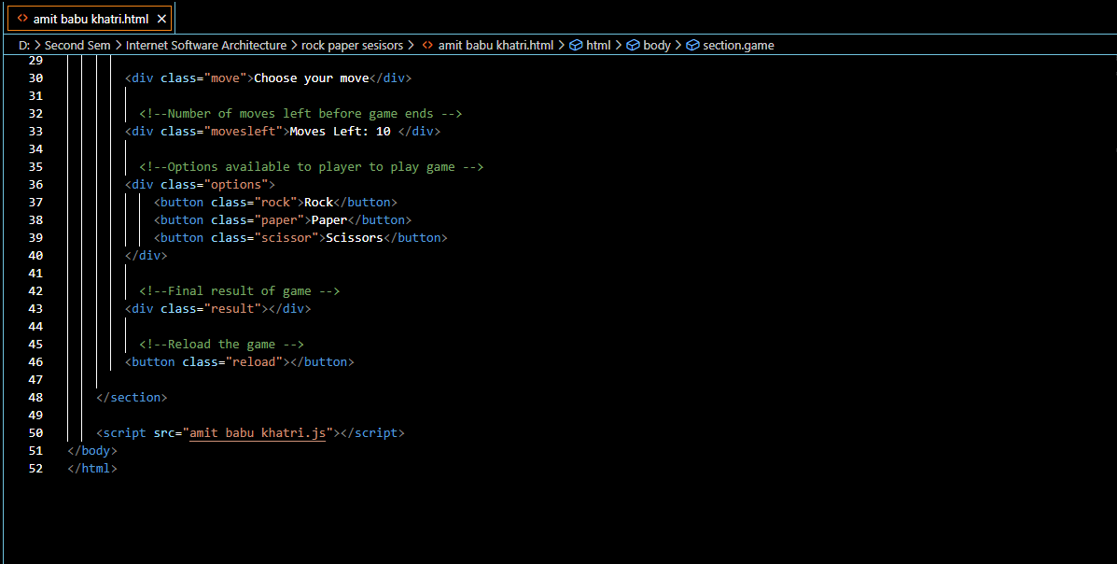

**CSS CODE:**

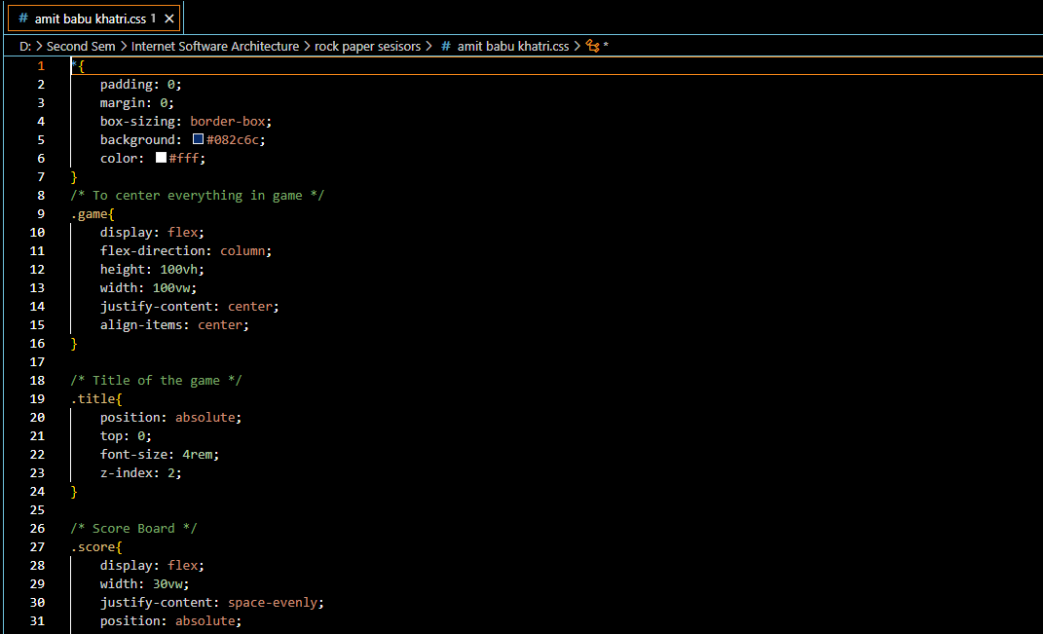

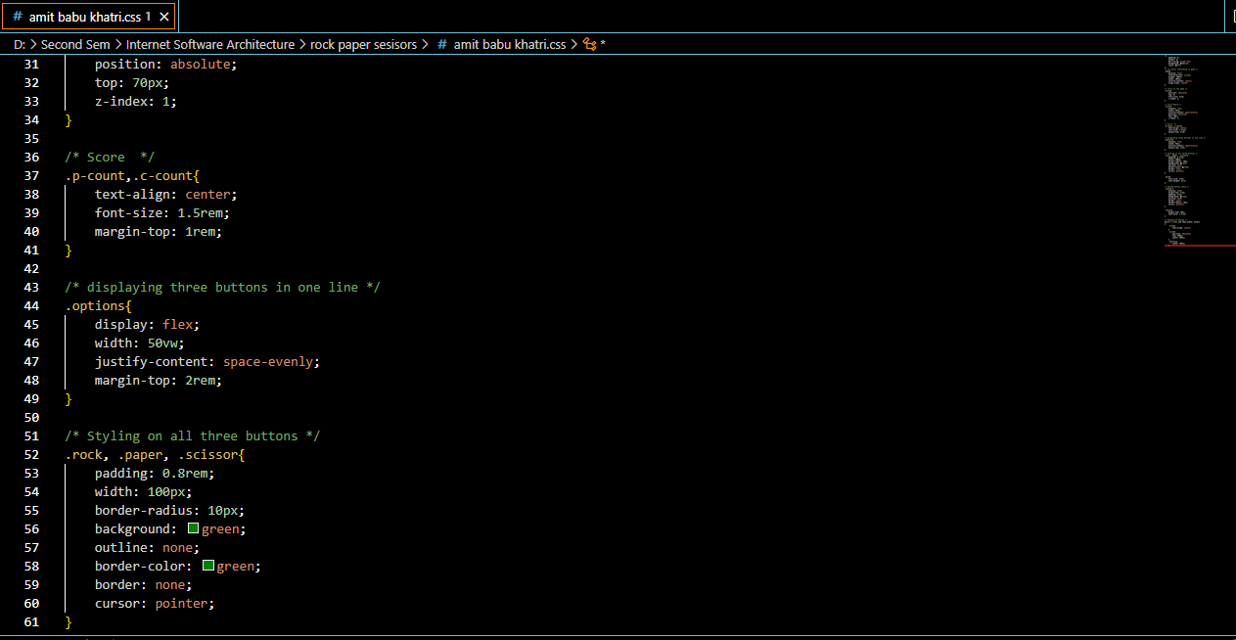

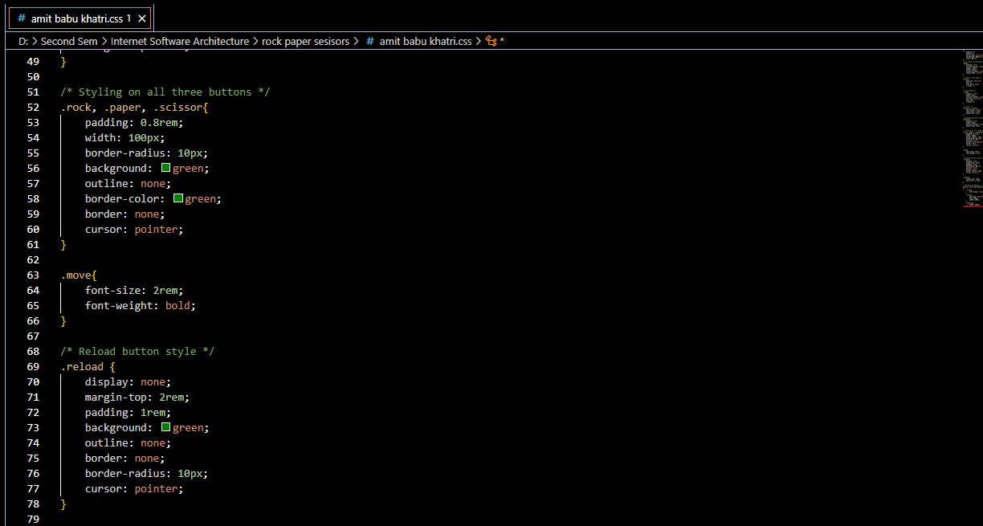

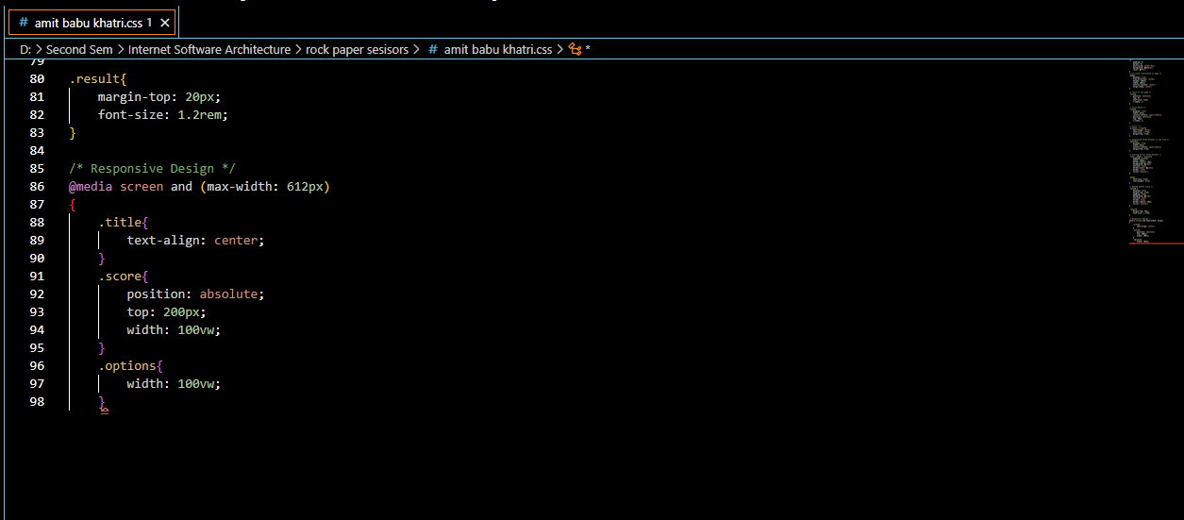

**JAVA SCRIPT CODE:**

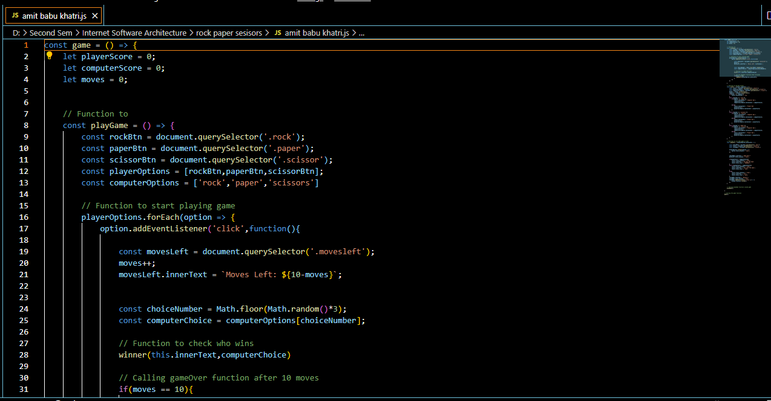

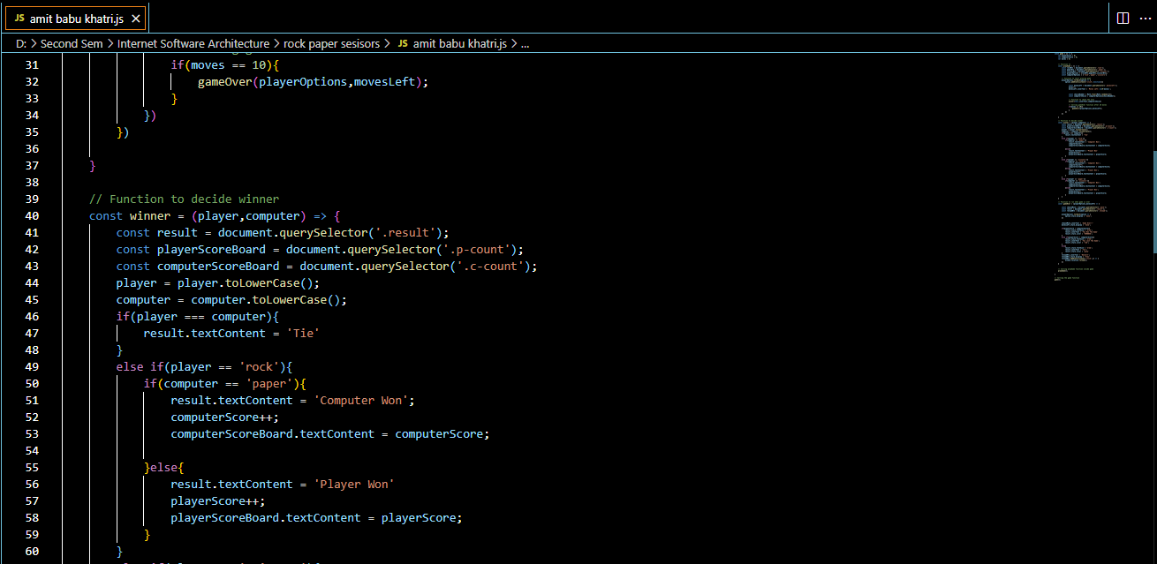

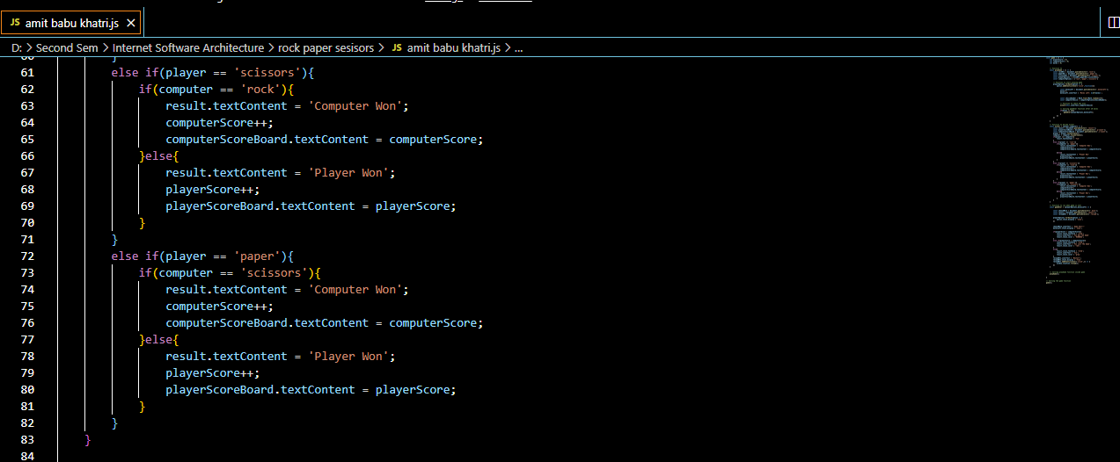

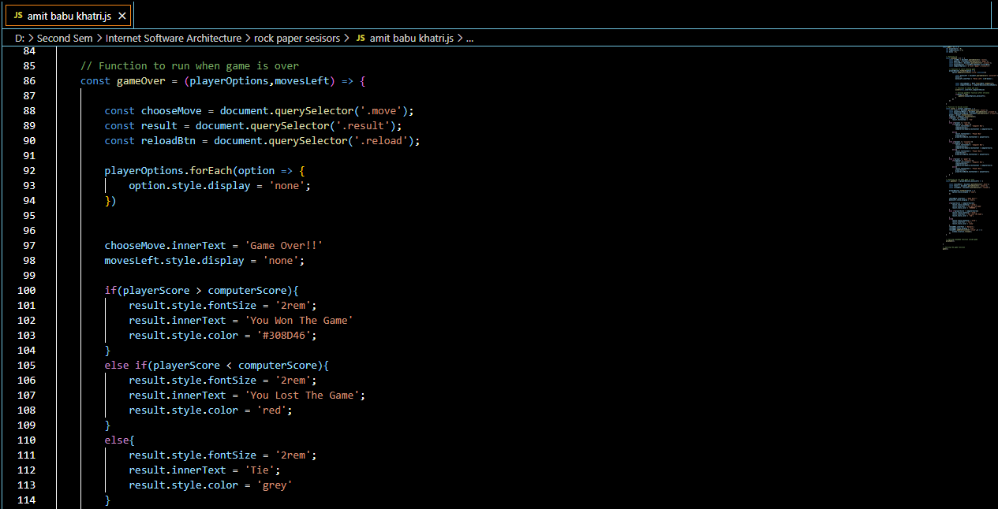

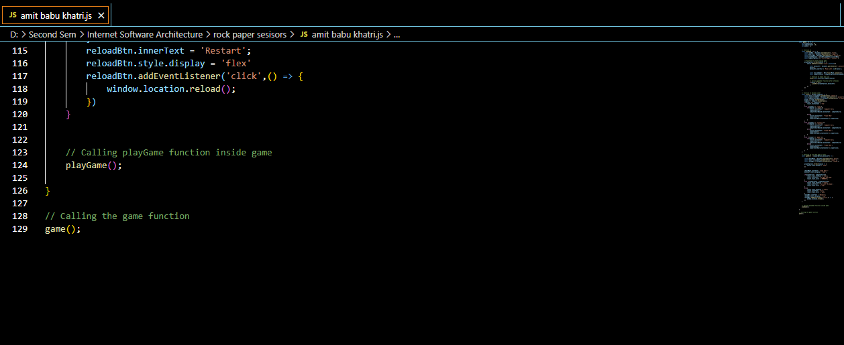

**RUNNING AND DEBUGGING OF CODE:**

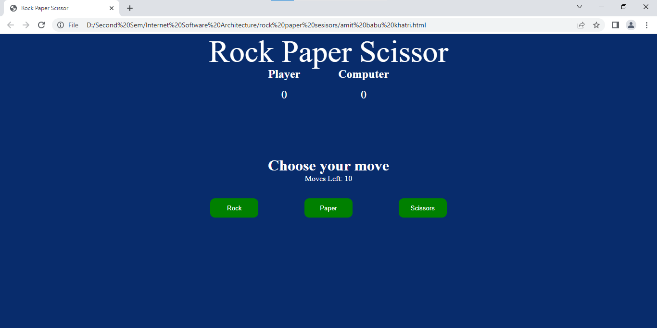

**Conclusion:**

Overall, this code sets up a basic implementation of the Rock Paper Scissors game using HTML, CSS, and JavaScript. Players can make their move by clicking the corresponding button, and the computer makes a random choice. The game keeps track of scores, displays the result, and allows players to restart after the game is over.

**From this code, we can learn about the following concepts:**

1.HTML structure and elements.

2.CSS styling and responsive design.

3.JavaScript event handling and DOM manipulation.

4.Implementing game logic using JavaScript functions.

5.Using variables to store and update game data.

6.Reloading the page using JavaScript.